**Project Management**

**Project Management-SPA:**

This application will help to add users, projects and tasks. We have 3 modules and 4 Screens

1. Add User
2. Add Project
3. Add Task

Below are the screens for reference.

Add User: Add user screen contains to add the user details as well as view the details of users and search and filter criteria.

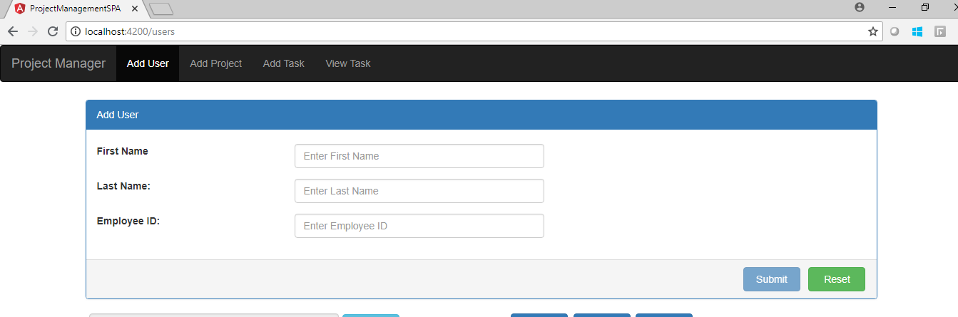

**View Users:**

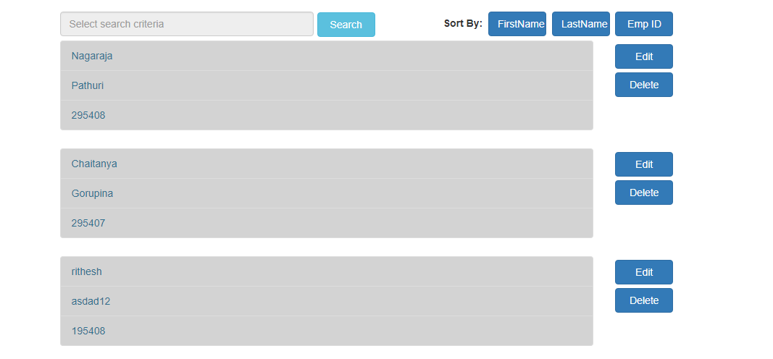

**Add Project:** Add project screen contains to add the project details as well as view the details of projects and search and filter criteria.

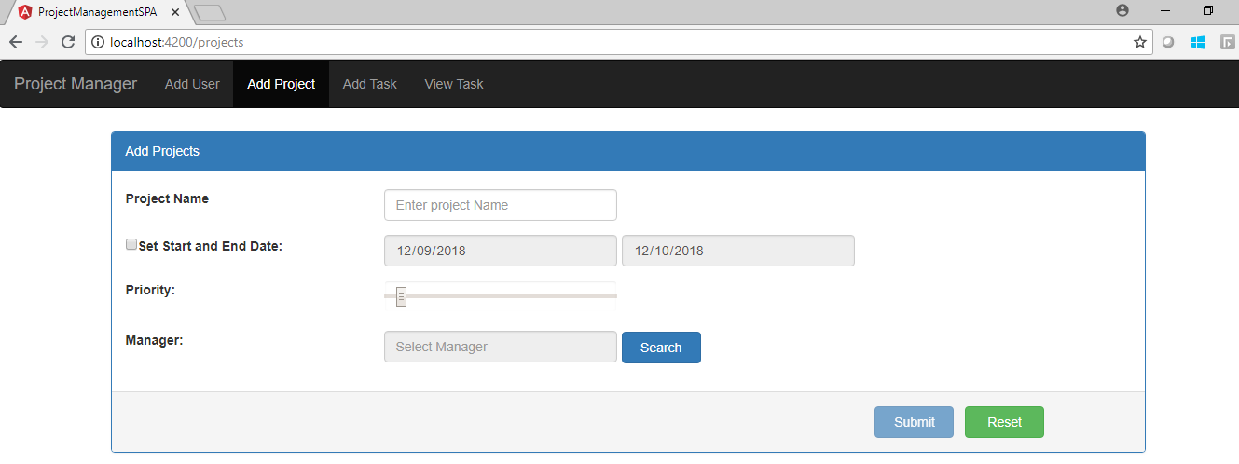

**View Projects:**

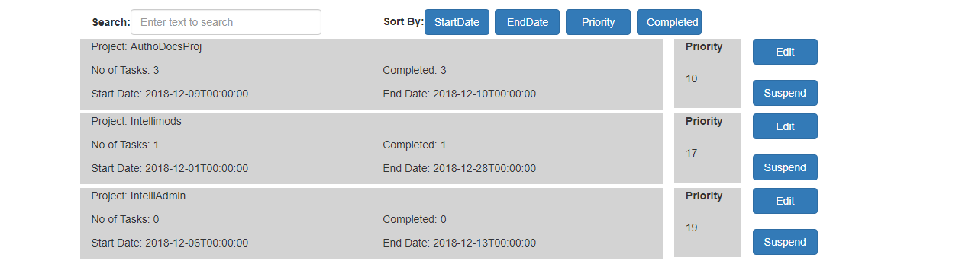

Add Tasks: Add task screen contains to add the task details .

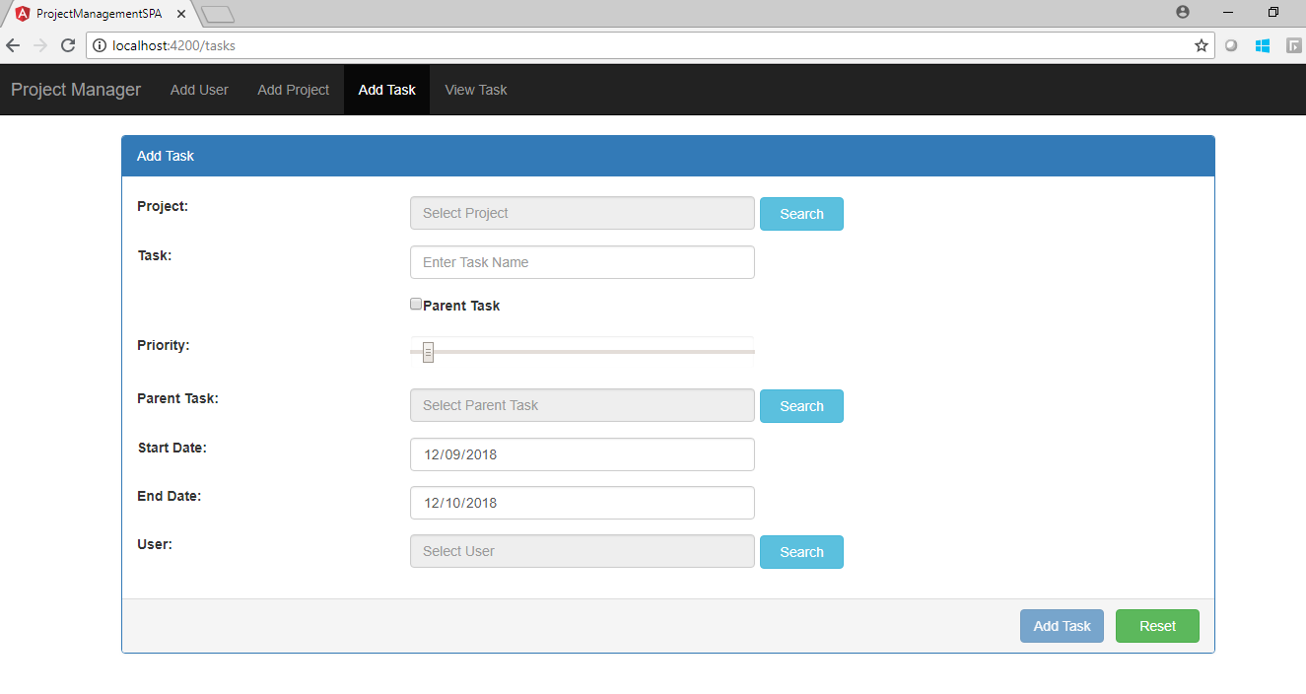

Popupwindow will look like below:

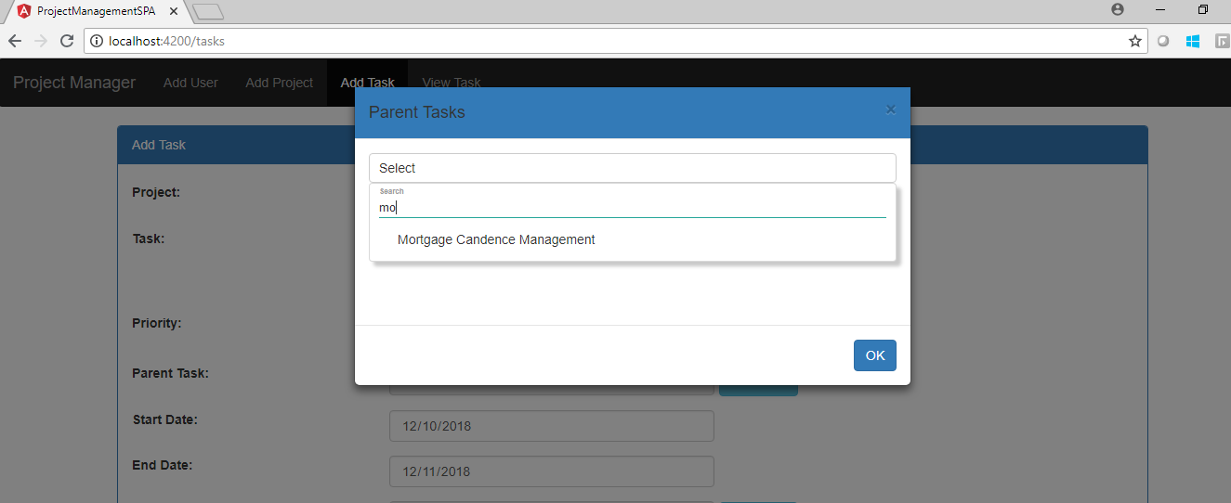

View Task: View task details contains the information like below.